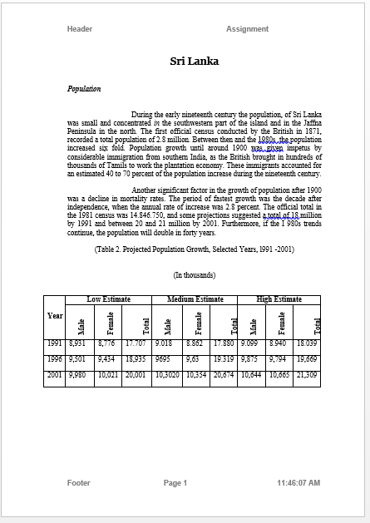
Sri Lanka
Population
During the early nineteenth century the population, of Sri Lanka was small and concentrated in the southwestern part of the island and in the Jaffna Peninsula in the north. The first official census conducted by the British in 1871, recorded a total population of 2.8 million. Between then and the 1980s the population increased six fold. Population growth until around 1900 was given impetus by considerable immigration from southern India, as the British brought in hundreds of thousands of Tamils to work the plantation economy. These immigrants accounted for an estimated 40 to 70 percent of the population increase during the nineteenth century.
Another significant factor in the growth of population after 1900 was a decline in mortality rates. The period of fastest growth was the decade after independence, when the annual rate of increase was 2.8 percent. The official total in the 1981 census was 14.846.750, and some projections suggested a total of 18 million by 1991 and between 20 and 21 million by 2001. Furthermore, if the I 980s trends continue, the population will double in forty years.
(Table 2. Projected Population Growth, Selected Years, l991 -2001)
(In thousands)
Year | Low Estimate |  |  | Medium Estimate |  |  | High Estimate
 | Male | Female | Total | Male | Female | Total | Male | Female | Total
1991 | 8,931 | 8,776 | 17.707 | 9.018 | 8.862 | 17.880 | 9.099 | 8.940 | 18.039
1996 | 9,501 | 9,434 | 18,935 | 9695 | 9,63 | 19.319 | 9,875 | 9,794 | 19,669
2001 | 9,980 | 10,021 | 20,001 | 10,3020 | 10,354 | 20,674 | 10,644 | 10,665 | 21,309

