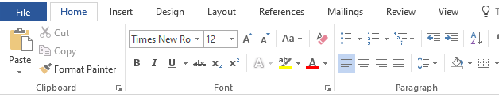
1
2
4
3
11
Opening a Document:
You can open a file by clicking on the "Open" folder icon (with a picture of a folder) located in the standard toolbar. Or, you can use the menu bar and navigate to File >> Open…
5
Microsoft Word 2003 Introduction
Introduction:
6

Microsoft Word is an essential tool for the creation of documents. Its ease of use has made Word one of the most widely used word processing applications currently on the market. Therefore, it's important to become familiar with the various facets of this software, since it allows for compati bility across multiple computers as well as collaborative features. Word is a fairly simple program to use for completing simple tasks. However, it may be
7
8
7
7
7
7
7

- Align Left:
9
MS-Powerpoint | MS-Word | MS-Excel | MS-Access
Animation | Document | Text | Query
Slide Show | Formatting | Numbers | Forms
Presentation | Page Setup | Formulae | Reports
- Center:
- Align Right:
- Justify:
- Numbering:
- Bullets
www.madeena.sch.lk
100

Opening a Document:
You can open a file by clicking on the "Open" folder icon (with a picture of a folder) located in the standard toolbar. Or, you can use the menu bar and navigate to File >> Open…
Microsoft Word 2003 Introduction
Introduction:

Microsoft Word is an essential tool for the creation of documents. Its ease of use has made Word one of the most widely used word processing applications currently on the market. Therefore, it's important to become familiar with the various facets of this software, since it allows for compati bility across multiple computers as well as collaborative features. Word is a fairly simple program to use for completing simple tasks. However, it may be

Align Left:
Center:
Align Right:
Justify:
Numbering:
Bullets

www.madeena.sch.lk

